Overall Consumption Trend (2017 – 2019): Gallons per Capita

*Source = National Institute on Alcohol Abuse and Alcoholism*

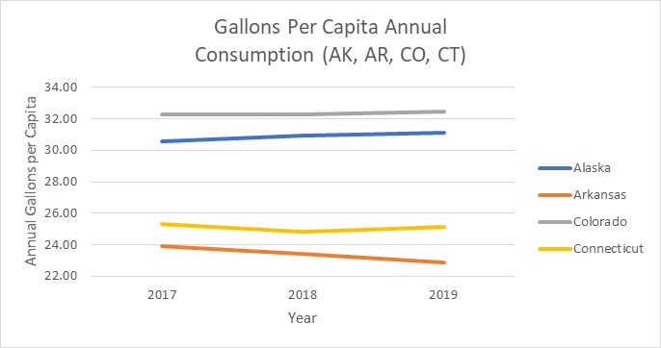

Overall Consumption Trend by Alcohol Type: Ethanol Consumption per Capita

*National Institute on Alcohol Abuse and Alcoholism*

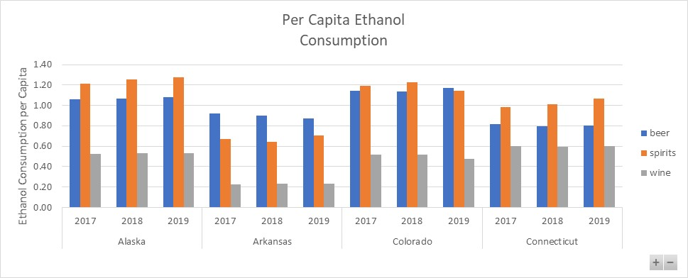

Gallons Per Capita Consumption by Month

*National Institute on Alcohol Abuse and Alcoholism*

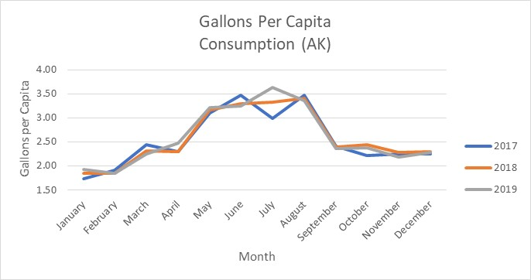

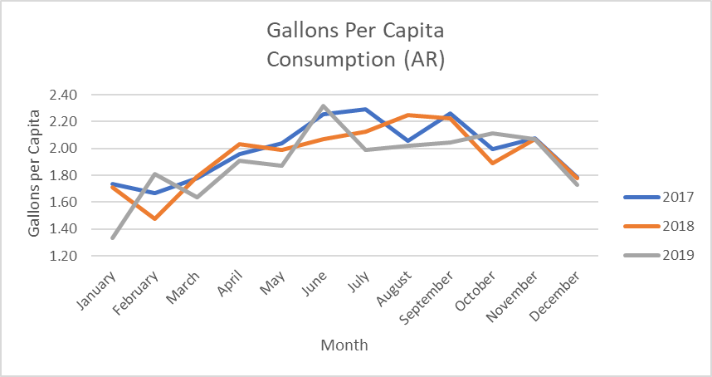

Gallons Per Capita Consumption by Month

*National Institute on Alcohol Abuse and Alcoholism*

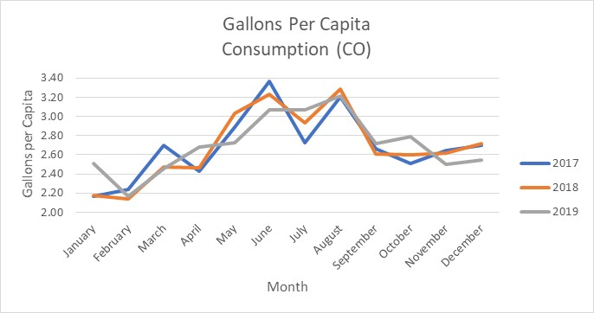

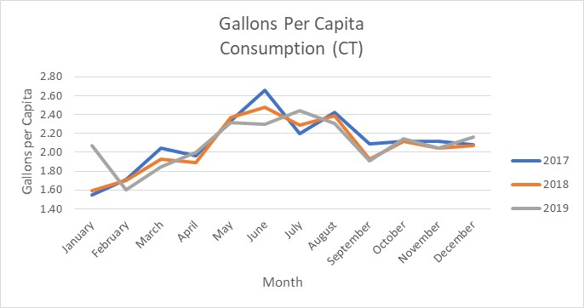

COVID Timeframe: Comparison of Gallons Per Capita Consumption

*National Institute on Alcohol Abuse and Alcoholism*

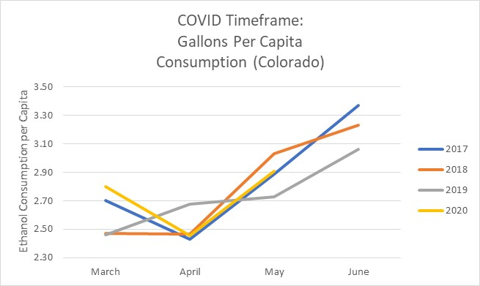

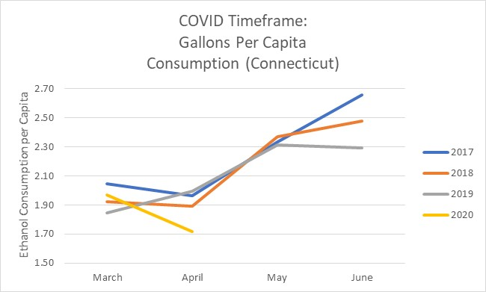

COVID Timeframe: Comparison of Gallons Per Capita Consumption

*National Institute on Alcohol Abuse and Alcoholism*

